**CS5250 Advanced Operating Systems**

**Pop Quiz 10**

Name: ___________Ding Fan______________________

Student Number: _____A0248373X_________________

Assuming the following initial B-trees:

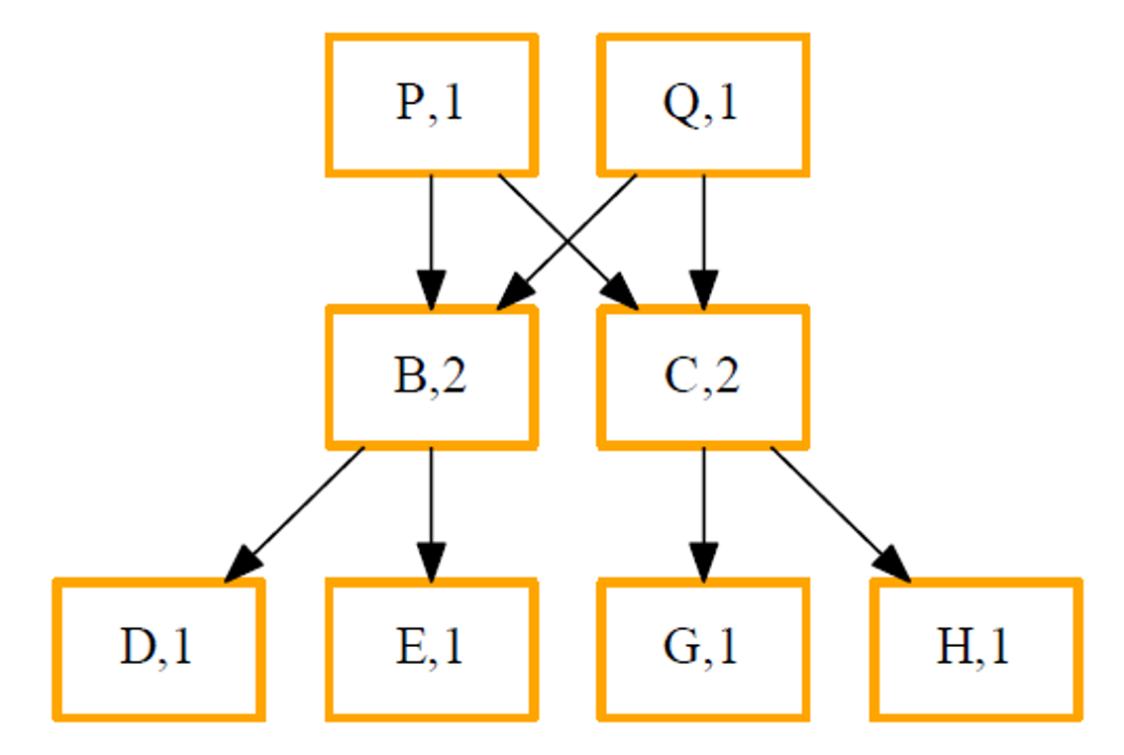

Show the steps involved in the COW-based leaf node E from tree P gets *updated*, along with the evolution of the reference counts, using the notations in the lecture slides. Clearly state any assumptions made.

Bonus question: what do you think are the downsides of such a clever algorithm?

**Solution:**

**The path from P to E includes node {P,B,E}**

卡通人物

手机屏幕截图

Downsides:

When a large number of write operations occurs, the performance overhead is relatively large.